**IoT Project Technical Report :**

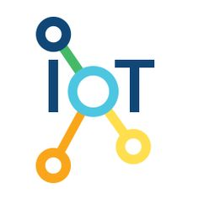

Vladislav ZOBOV - 6218000239

Grégoire RENARD - 6218000234

Nicolas GUEGUEN - 6218000229

姚苏丹 - 2018218081

Summary

Project introduction 3

Technology Used 4

Arduino Uno 4

2 HC-SR04 Ultrasonic sensors 7

Panel control sensor 9

8 digit display 10

Captors Implementation 11

Conclusion 13

# Project introduction

Our project consisted in an innovative and simple way to help an enterprise manage its employee’s presence.

The idea is thus. When someone enters the enterprise building, they are noticed and then have to type their personal code so that the administrator could verify who the person is. If the verification code is valid the system will greet the person in question, then they can proceed further in the building.

Then, when one goes out, they are also noticed, must retype their personal code, the administrator verifies once again who they are, know how long they have worked and greet them.

# Technology Used

To realize our project, we used:

## Arduino Uno

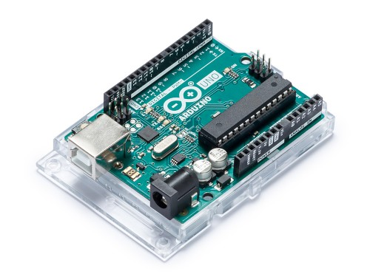

The Arduino Uno microcontroller board is powered by the ATmega328. It has an input voltage of 7-12V, 32k of Flash memory and a clock speed of 16Mhz. On the board you can utilize 14 Digital I/O Pins including 6 PWM outputs plus 6 Analog Inputs.

Arduino Uno board is a very convenient technology for work and test different kinds of captors we wished to implement into our project.

We used it as the base for our project and after some research, we find some interesting captors to make a project around them.

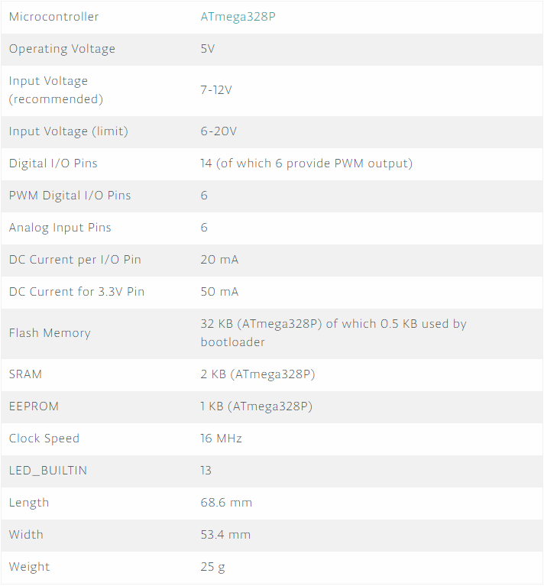

Arduino UNO TECHNICAL SPECS

## 2 HC-SR04 Ultrasonic sensors

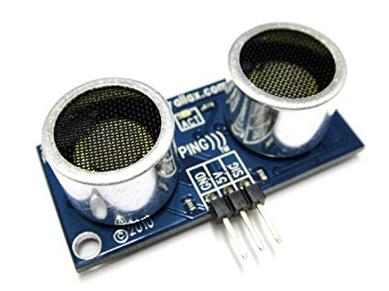

Our idea was to use two Ultrasonic sensors to detect a presence of a human passing between the range of this captors and then to use it to enhance the purpose of our project.

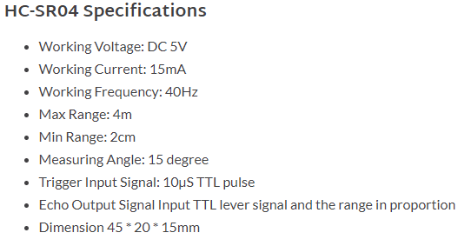

HC-SR04 Datasheet

## Panel control sensor

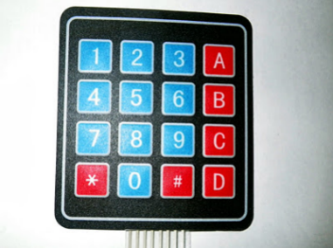

As for the panel control sensor we used it to identify the person, and then if the entered code is valid, the person can proceed freely in the building.

## 8-digit display

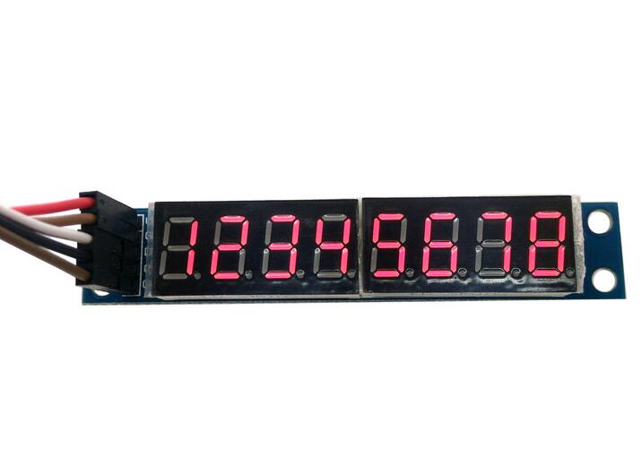

The 8-digit display show the person the code they entered.

# Captors Implementation

I will show some implementation code we used to make our captors to work:

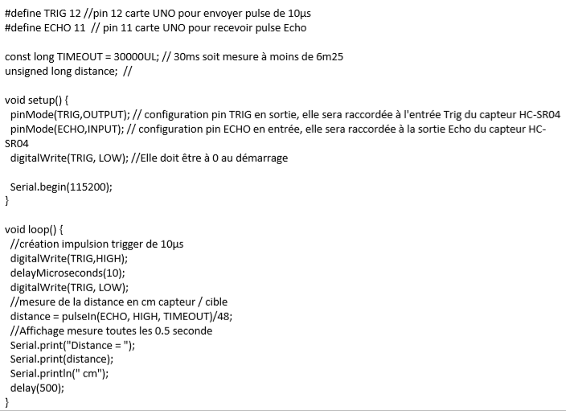

Ultrasonic Sensor Test Code

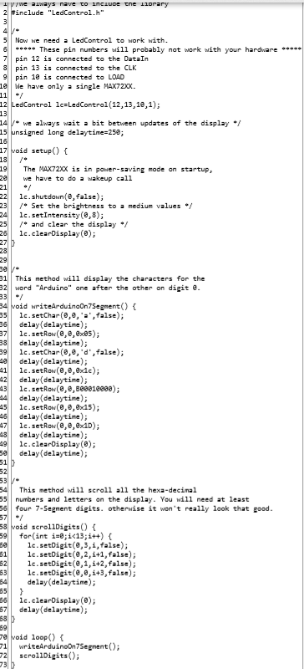

8-digit display code

# Conclusion

We learned a lot during this project:

The application of Arduino in an IoT project, implementation of different kinds of captors we worked with, extract and work with data we collect through our captors.

It’s a good experience for us to work on the project with the IoT purpose, we learned a lot of new things and reinforced our base knowledge.